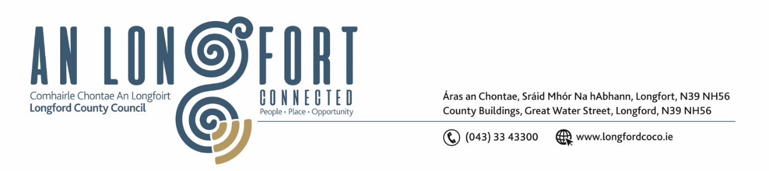

**LONGFORD MUNICIPAL DISTRICT**

**Minutes of Meeting of Longford Municipal District held via MS Teams**

**on Wednesday, 23 February 2022 at 3.30pm**

**CATHAOIRLEACH**: Councillor Uruemu Adejinmi

**MEMBERS PRESENT**: Councillors – Seamus Butler, Martin Monaghan,

John Browne, Peggy Nolan, Gerry Warnock,

Gerry Hagan.

**IN ATTENDANCE**: Mr. John Brannigan, Director of Services.

Mr. Eamonn Bennett, Senior Executive Engineer.

Ms. Lorraine Mc Kee, Administrative Officer.

**MEETINGS**

**ADMINISTRATOR:**  Ms. Ann Marie Mc Keon

**ADOPTION OF MINUTES – circulated**

On the proposal of Councillor Peggy Nolan seconded by Councillor Seamus Butler, it was unanimously agreed to adopt Minutes of Committee Meeting of Longford Municipal District held on the 26 January 2022.

On the proposal of Councillor John Browne seconded by Councillor Gerry Hagan, it was unanimously agreed to adopt Minutes of Committee Meeting of Longford Municipal District held on the 8 December 2021.

**MATTERS ARISING FROM MINUTES**

Councillor Seamus Butler welcomed the news on the interviews for the Community Warden.

**DECLARATION OF INTEREST BY MEMBERS**

Councillor Seamus Butler declared that he is a member of the Chamber of Commerce and the group have submitted an application for funding which is to be considered at today’s meeting under the Community Grant Support Scheme 2022.

**MANAGEMENT REPORT INCORPORATING AREA ENGINEER’S PROGRESS REPORT – circulated**

Eamonn Bennett, Senior Executive Engineer briefed the members on the Management Report and responded to questions raised by the members on the following:

* Footpaths at Shannonvale and Battery Road
* RFT for footpath works
* Newtownforbes works
* Active Travel

**PROPOSED PROJECTS/EXPRESSION OF INTERESTS**

Noted.

**CONSIDERATION OF APPLICATION FOR FUNDING UNDER THE 2022 COMMUNITY GRANT SUPPORT SCHEME -AS CIRCULATED**

On the proposal of Councillor Uruemu Adejinmi, seconded by Councillor Gerry Warnock it was unanimously agreed to provide funding of €8,500 to the Chamber of Commerce for the St. Patrick’s Day Parade subject to the following condition: Longford County Council are the main sponsors of the event.

**UPDATE ON PROJECT IN LONGFORD TOWN**

This item was discussed with members at an earlier meeting of Longford Municipal District.

**TAKING IN CHARGE “LEADER PARK” – AS CIRCULATED**

On the proposal of Councillor John Browne, seconded by Councillor Seamus Butler the members unanimously agreed to take in charge Leader Park as per the report circulated.

**SUBMISSION OF NOTICE OF MOTIONS FOR AGENDA**

The members unanimously agreed to trial the new system on the submission of Notice of Motions and to take part in the upcoming training to be provided by IT.

**NOTICES OF MOTIONS**

**CCTV Royal Canal Spur Gateway Project**

The following Notice of Motion was proposed by Councillor Gerry Warnock and seconded by Councillor Seamus Butler -

In anticipation of the commencement of the Royal Canal Spur Gateway Project later this year and the future development of the recently acquired Longford Greyhound Track Site, I am proposing that we prepare a plan for the extension of the CCTV Network to take in the proposed public space at the Rear of the Market Square (Old Harbour Site); the beginning of the existing Longford Canal Walk on the green area directly past the railway bridge (Harbour View) between Farranyoogan Estate and Canal Bank Estate; approval in principal for units at Longford Greyhound Track to be incorporated into the agreed development plan for that site. These areas have a history of antisocial activity (Dumping, Public Drinking & Drug Dealing) and the placement of these cameras would provide peace of mind for residents and for all who use the amenity for sport and recreation. I am proposing that this plan be prepared and forwarded to the CCTV Monitoring Committee so they can make a recommendation for the consideration of the elected members, so we can have this ready to go before construction phase of the Canal Spur Gateway Project.

Response

This motion will be forwarded to the CCTV Monitoring Committee for consideration.

**Footpath on Demesne Lane**

The following Notice of Motion was proposed by Councillor Martin Monaghan and seconded by Councillor Gerry Warnock –

“I am call on the Longford Municipal District to seek funding to install a footpath on the

Demesne Lane. This area of the town has been growing steadily over the last few years, with

added housing and a sports facility namely Longford Tennis Club.”

Response

The installation of a footpath on the Demesne lane will require major funding as the works will involve land purchase, replacement of fencing and walls, landscaping and the installation of public lighting. Since this road is within a 50km/hr speed limit and has an existing sports facility on the roadway as well as a large housing estate at the end of this road so it will qualify for an active travel scheme. An application I discussed this with Brian Kelly in the planning & Project delivery directorate, and he will apply to the National Transport authority for funding of an Active Travel scheme on the Demesne Lane in 2023

**Low Cost Safety Scheme at Kelleter Lane**

The following Notice of Motion was proposed by Councillor Gerry Hagan and seconded by Councillor Peggy Nolan -

“I call on Longford Municipal District to carry out a low-cost safety scheme along the Ballinalee Longford road from the junction of the Kelleter lane towards Longford”.

Response

Longford County Council previously applied for a low-cost safety scheme at the junction of the R-194 and the Kelleter lane as there is a safety issue with sight distance at this junction. The scheme did not qualify for priority funding due to a lack of accident history. It is currently included on a supplementary list of low-cost schemes.

**Sympathy**

On the proposal of Councillor Martin Monaghan, the members unanimously agreed to extend a vote of sympathy to Wexford County Council and the work colleagues of the late Billy Kinsella who was fatally injured in a workplace accident. “Our thoughts and prayers are with the employee’s, family, work colleagues and friends at this very difficult time”.

This concluded the business of the meeting.

Ann Marie Mc Keon

**Signed: ____________________**

**Ann Marie Mc Keon**

**Meetings Administrator.**

**Confirmed and adopted at Longford Municipal District Meeting held on the 23 March 2022.**

Uruemu Adekinmi

**Signed: _______________**

**Cathaoirleach.**